Periodica Polytechnica
Chemical Enginering
Chemical Engineering
x(y) pp. x-x, (year)
doi: 10.3311/pp.tr.201xx.xx
Creative Commons Attribution O
RESEARCH ARTICLE
Assessing toxicity of organic aquatic micropollutants based on the total chlorophyll content of Lemna minor as a sensitive endpoint
Ildikó Fekete-Kertész¹, Zsuzsanna Kunglné-Nagy¹, Katalin Gruiz¹, Ádám Magyar¹, Éva Farkas¹, Mónika Molnár¹
Received 201x-xx-xx

Abstract
The present study examined the chlorophyll content in a 7 days contact time experiment series. Lemna minor was exposed to caffeine, benzophenone, bisphenol A, 3,4-dichlorophenol, metamizole-Na, Na-diclofenac, acetochlor, atrazine, diuron, metazachlor and metolachlor to find a convenient sensitive response to the tested chemicals including some emerging micropollutants. The results demonstrated the differences in sensitivity to the tested micropollutants. As anticipated the industrial chemicals and the pesticides were the most toxic. The lowest observed effect concentration (LOEC) values determined for 3,4-dichlorophenol, acetochlor, diuron, metazachlor and metolachlor were 2.5 µg/L, 0.05 µg/L, 0.5 µg/L, 5 µg/L and 0.5 µg/L, respectively. These values were comparable with the environmental concentrations reported in literature. Our study provides valuable information on the feasibility of Lemna minor total chlorophyll method as a sensitive and reliable bioassay for testing toxicity at µg/L range and it may support risk assessment of organic micropollutants in freshwater ecosystems.
Keywords
Lemna minor, chlorophyll content, emerging micropollutants, pesticides, pharmaceuticals, industrial additives
Acknowledgement
The financial support of National Innovation Office (TECH_08-A4/2-2008-0161, CDFILTER and TECH_09-A4-2009-0129, SOILUTIL project) is greatly acknowledged. The authors gratefully appreciate KISCHEMICALS Manufacturing and Mercantile LLC and Peters&Burg Ltd. for supporting the atrazine, diuron, metolachlor and acetochlor test substances. We are grateful to Emese Vaszita for contribution to language editing of the manuscript. We acknowledge Sándor Kemény’s contribution to statistical evaluation of the results.

¹Department of Applied Biotechnology and Food Science,
Budapest University of Techology and Economics
H-1111 Budapest, Szent Gellért sqr. 4., Hungary (email: fekete.kertesz.ildi@gmail.com, mmolnar@mail.bme.hu)

Introduction
Pollution of the aquatic ecosystems is a serious problem worldwide. Many articles report about micropollutants found in treated wastewaters, drinking water and surface or subsurface waters at trace concentrations. These chemical substances represent possible environmental and human health risk [1, 2, 3, 4]. Emerging pollutants (EPs) are referred to as new chemicals because they have recently been analyzed and their impact on human health and environment are not understood properly [5]. The main sources of these emerging pollutants and pesticides are from industrial, municipal and agricultural applications [1, 2, 3, 6]. Municipal wastewaters and hospital effluents may contain pharmaceuticals, personal care products (PPCPs), industrial additives and pesticides, etc. which cannot be eliminated by the conventional wastewater treatment technologies [7, 8, 9, 10, 11, 12, 13].
Many micropollutants and the above mentioned EPs have no regulatory status and most of them are not considered priority pollutants of concern. So the importance of detecting contaminants in the environment and studying their impacts has resulted in the development and adoption of numerous chemical analytical and ecotoxicological methods [14, 15]. Chemical analytical methods have several limitations. The chemical analytical methods do not take into account changes in exposure and availability of pollutants therefore they do not provide ecologically relevant information. Moreover the sample preparation is a complex procedure and chemical analysis needs expensive equipment and reagents [16, 17]. To compensate these drawbacks numerous ecotoxicological tests including also plants tests have been developed and applied to investigate the adverse effects of the above mentioned chemical substances [4, 16, 18, 19, 20, 21].
The objective of this work was to identify the environmental toxicity of different micropollutants, especially emerging pollutants and pesticides to the Lemna minor aquatic macrophyte.
Aquatic and terrestrial plants are sensitive test organisms to numerous environmental pollutants and have been used for monitoring the toxic effects in water quality studies. Freshwater plants are considered usually less sensitive to chemicals than animal species, but aquatic macrophytes were found to be more sensitive to some toxic metals and pesticides than fish [22, 23].
Duckweeds (Lemnaceae) are key components of freshwater ecosystems. Lemna minor compared to algae is a new test organism, which is widespread all over the world; it is a vascular plant floating on the water surface. Two different species are widely applied in ecotoxicity studies, the L. minor and L. gibba. Because of its small size, simple structure (root and leaves) and thanks to its vegetative propagation and easy cultivation L. minor is an ideal test organism. The doubling time of the leaves is between 0.35–2.8 days, the tests are simple and cost effective. There are a number of different test methods applying L. minor for environmental toxicology assessment. The duration of these tests is usually 4–7 days. The most commonly measured parameters are the frond number, biomass production, leaf diameter and root length [24, 25].
In recent years, scientists have primarily dealt with the effects of heavy metals on Lemna species, using different measurement endpoints. Drost et al. [26] studied the effect of heavy metals applying fluctuating concentrations in time, thereby modelling the exposure of the test organism to varying pollutant concentrations in the environment. They found that at low pollutant concentrations a so-called recovery phase occurs. After 7 days of exposure Cd and Cu resulted EC₅₀=1.9 and 9.7 µM respectively, Ni and Zn resulted EC₅₀=56.3 and 46.1µM respectively in case of growth rate toxicity endpoint. Dirilgen [27] investigated the synergistic effects of heavy metals on the growth rate of L. minor, and found that the simultaneous application of lead and mercury caused synergistic toxic effects, mutually reinforcing each other. The EC₅₀(7 days) value for Pb was 5.5 mg/L, while the EC₅₀(7 days) value for Hg was 0.48 mg/L. Horvat et al. [28] studied the feasible utility of L. minor for multi-component samples containing heavy metals. The applied toxicity endpoints were relative growth rate, Nfronds/Ncolonies ratio, dry to fresh weight ratio and frond area. They also measured guaiacol peroxidase activity as early indicator of oxidative stress. Based on the results, not only single-component samples, but multi-component samples containing heavy metals can be studied successfully. Park et al. [17] developed, proposed and applied a novel method applying root re-growth as a sensitive endpoint for testing toxicity of metals. For Ag the EC₅₀ value was 5.3–37.6 µg/L, for Cu EC₅₀=470.4 µg/L. Gubbins et al. [29] studied the toxic effects of nano-silver on L. minor, the results showed that nanomaterials may have harmful effects on the ecosystem. 5 µg/L silver nanoparticle caused inhibition of plant growth which became higher with a longer exposure time. Radic et al. [20] determined the toxicity and genotoxicity of surface water samples using L. minor applying growth parameters and other endpoints such as pigment content, peroxidase activity, lipid peroxidation and alkaline comet assay. Juneau et al. [30] determined the toxicity of various water samples measuring the total chlorophyll fluorescence of L. gibba. An alga species (C. ehrenbergii) proved to be 400 times more sensitive to hydrophobic components than L. gibba.
The single or joint toxicity of different pesticides and degradation products to the aquatic environment has been also widely investigated/tested using Lemna species [16, 21, 31, 32, 33, 34, 35]. Toxic effect of pesticides was generally evaluated by growth inhibition, but sometimes the sensitivity of this endpoint was not adequate compared to the environmentally realistic effect concentration values.
Currently, little literature is available on the potential hazardous effect of emerging pollutants on Lemna species. Although Cedergreen et al. [36] and Gorzerino et al. [37] tested the toxicity of various pesticides on L. minor, their studies did not cover any emerging pollutant type such as pharmaceuticals, industrial additives and agents or personal care products.
Brain et al. [38] studied eight different pharmaceuticals (atorvastatin, acetaminophen, caffeine, sulfamethoxazole, carbamazepine, levofloxacin, sertraline, and trimethoprim). In case of L. gibba a clear concentration-effect was observed.
Table 1 shows the Lowest Observed Effect Concentration (LOEC), the No Observed Effect Concentration (NOEC) and the median effective concentration (EC₅₀) data from current literature concerning the investigated substances in our research.
Based on these facts L. minor is a promising test organism to study the effect of micropollutants. The main objective of our study was to provide information on different micropollutants including several emerging compounds and pesticides applying the total chlorophyll content as endpoint in the Lemna minor growth assay, which according to the current literature is scarecely applied for the testing of micropollutants.
- Selected EC₅₀, NOEC and LOEC values from current literature about the freshwater toxicity of the tested micropollutants on Lemna minor and Lemna gibba
Chemical substance | Ecotoxicity parameter | Concentration | Endpoint | Ref.
Caffeine | LOEC (7 d) | 0.608 µmol/L | frond number¹ | [38]
Caffeine | EC₅₀ (7 d) | 12.3 µmol/L | chlorophyll-a¹ | [38]
Caffeine | EC₅₀ (7 d) | 5.38 µmol/L | chlorophyll-b¹ | [38]
Bisphenol A | EC₅₀ (7 d) | 32 mg/L | growth rate¹ | [40]
Bisphenol A | NOEC (7 d) | 7.8 mg/L | frond biomass¹ | [40]
Diclofenac | EC₅₀ (7 d) | 7.5 mg/L | total frond area² | [41]
Diclofenac | EC₅₀ (7 d) | 47.6 µg/L | population abundance² | [42]
Acetochlor | EC₅₀ (14 d) | 3.4 µg/L | population abundance¹ | [43]
Atrazine | EC₅₀ (10 d) | 56 µg/L | abundance, frond number² | [44]
Diuron | EC₅₀ (7 d) | 28.3 µg/L | frond number² | [31]
Metazachlor | EC₅₀ (7 d) | 2.8 µg/L | frond area² | [45]
Metolachlor | EC₅₀ (5 d) | 21 µg/L | population abundance¹ | [43]
¹Test organism: Lemna gibba
²Test organism: Lemna minor

Materials and methods

2.1 Chemicals
Nicotine (N0267-100MG, ≥99% TLC liquid, CASRN: 54-11-5), 3,4-dichlorophenol (99%, D70406-5G, CASRN: 95-77-2); benzophenone (B9300-25G-A, 99%, CASRN: 119-61-9), metolachlor (36163-100MG-PESTANAL®, analytical standard-FLUKA, CASRN: 51218-45-2), bisphenol A (239658-50G, ≥99%, CASRN: 80-05-7), Na-diclofenac (D6899-10G, CASRN: 15307-79-6) and acetochlor (33379-100MG-PESTANAL®, analytical standard-FLUKA, CASRN: 34256-82-1) were purchased from Sigma Aldrich; Metazachlor (Sultan 50SC, CASRN: 67129-08-2) was purchased from Makhteshim-Agan Industries Ltd. Israel with 500g/L metazachlor content. Atrazine (>97.0%, CASRN: 1912-24-9) and diuron (>97.0%, CASRN: 330-54-1) were supported by KISCHEMICALS Manufacturing and Mercantile LLC. Caffeine (CASRN: 58-08-2) and Metamizole-Na (CASRN: 8017-81-0) pharmaceutical drug were manufactured by Sanofi-Aventis Ltd. at Veresegyház (Hungary).
Standard solutions were prepared from these chemical substances according to their water solubility. The standard solutions were introduced without further treatment into the test systems. The applied nominal concentrations were the following: nicotine: 1000; 500; 50; 5; 0.5 mg/L, 3,4-dichlorophenol: 2.5; 0.25; 0.025; 0.0025; 0.00025; 0.000025 mg/L. Acetochlor, metolachlor, atrazine and diuron in 5; 0.5; 0.05; 0.005; 0.0005; 0.00005 mg/L concentration, caffeine and metamizole-Na in 100; 10; 1; 0,1; 0,01 mg/L concentration, Na-diclofenac, metazachlor and bisphenol A in 50; 25; 12,5; 6,25, 3,125 mg/L concentration and benzophenone in 25; 12,5; 6,25, 3,125;1,5625 mg/L concentration.

2.2 Test organism
A colony of Lemna minor cultured in the laboratory was used in this experiment. The applied growth medium was the original Hoagland's nutrient medium (Missouri Botanical Garden). All salts were dissolved in distilled water. The test organism was cultured in a 20x30x7 cm glass container in a 21.5±1°C thermostat with 16:8 hr light: dark cycle (illumination: Juwel Aquarium, Day-Lite, 15W, 438 mm lamp, 560 Lumen, 6500 K). Healthy, two-leaf L. minor individuals cultivated in Hoagland's nutrient medium were used for the test.

Hoagland's nutrient medium
MgSO₄·7H₂O (24.6 g/100 mL): 1.0 mL/L
Ca(NO₃)₂·4H₂O (23.6 g/100 mL): 2.3 mL/L
KH₂PO₄ (13.6 g/100 mL): 0.5 mL/L
KNO₃ (10.1 g/100 mL): 2.5 mL/L
Microelement solution: 0.5 mL/L
Fe-EDTA solution: 20.0 mL/L

Microelement solution:
H₃BO₃ 2.86 g/L
MnCl₂·4H₂O 1.82 g/L
Na₂MoO₄·2H₂O 0.09 g/L
CuSO₄·5H₂O 0.09 g/L
ZnSO₄·7H₂O 0.22 g/L

Fe-EDTA solution:
FeCl₃·6H₂O
0.121g/ 250mL
EDTA
0.375g/ 250 mL

2.3 Lemna minor bioassay
The experiment was carried out with three parallels in 150 cm³ beakers. On the first day 10 healthy and two-leaf L. minor individuals were placed into 50 mL of each dilution member of the test solutions. Hoagland's nutrient medium was applied as control. The beakers were covered with a translucent plastic film to avoid evaporation and concentration of the test solutions during the experiment. The assembled test systems (beakers) were incubated in a 21,5 ± 1°C thermostat for 7 days under the following light conditions: 16:8 hr light:dark cycle (illumination: Juwel Aquarium, Day-Lite, 15W, 438 mm lamp, 560 Lumen, 6500 K).
On the seventh day L. minor individuals were removed from the test solutions, then surface-dried on filter paper to constant weight. The dried biomass was placed into ground-necked test tubes containing 5 mL of 96% ethanol. After 24 hours the optical density of the samples was determined spectrophotometrically (Sanyo SP55 UV/VIS spectrophotometer) at 470, 649 and 664 nm wavelength values.
The total chlorophyll content was determined for all tested chemical substances. The tested chemical substances were dissolved in the original Hoagland's nutrient medium in a series of five or six members decimal or twofold dilution explained above.
For three selected model compounds (nicotine, Na-diclofenac and 3,4-dichlorophenol) the correlation between the frond number and the total chlorophyll content as measurement endpoints was also examined and evaluated in a preliminary experiment . The inhibition effect of nicotine, Na-diclofenac and 3,4-dichlorophenol on the frond number and the total chlorophyll content was followed and determined in a 7 days contact time experiment.
  - Evaluation and interpretation of results – statistical analysis
From the measured optical density values the total chlorophyll content was determined using the following formula [39]:

$C_{a_{+b}}=(5\text{.}\text{24}⋅A_{\text{664}}+\text{22}\text{.}\text{24}⋅A_{\text{649}})∗E$ ()

where:
C_{a+b}: total chlorophyll content of the sample (µg)
A₆₆₄: absorbance values at 664 nm wavelength
A₆₄₉: absorbance values at 649 nm wavelength
E: the amount of EtOH (96%) applied for the extraction (mL)
One-way analysis of variance (ANOVA) was performed by STATISTICA 12® software identifying significant effects (p<0.05). Univariate Tests of Significance were performed and the homogeneity of variances was examined. In case of significance the lowest observed effects concentration value (LOEC) was determined using Dunnett's test (α = 0.05).

Results
The correlation between the frond number and the total chlorophyll content was determined in a preliminary experiment. We found, that there is a linear correlation (y = 0.648 x – 0.0572; R² = 0.9774) between frond number and total chlorophyll content in the control (uncontaminated) samples.
But three selected model compounds (Na-diclofenac, nicotine and 3,4-dichlorophenol) caused higher inhibition of the chlorophyll content than of the frond number (Fig. 1). These chemicals may have caused chlorosis manifested in the loss of chlorophyll content however not yet necrosis and disintegration in fronds of the affected plants.
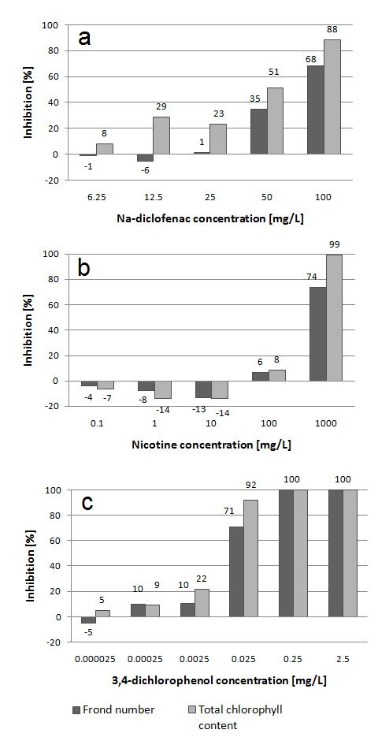
- Inhibition effect of Na-diclofenac (a), nicotine (b) and 3,4-dichlorophenol (c) on the frond number and the total chlorophyll content expressed in inhibition percentage (H%).
Thus, in case of Na-diclofenac, nicotine and 3,4-dichlorophenol the chlorophyll content proved to be a more sensitive endpoint than the conventionally applied frond number.
The total chlorophyll content was determined for 5 pesticides (metazachlor, acetochlor, metolachlor, atrazine and diuron) and 5 other micropollutants (caffeine, metamizole-Na, Na-diclofenac, bisphenol A and benzophenone). The following STATISTICA 12 BoxPlot diagrams show the effect of the micropollutants on Lemna minor at different concentrations where 0 refers to the control group. From these diagrams we can see which concentration caused significant decrease in the total chlorophyll content compared to the total chlorophyll content of the control group (Fig. 2–3). The significant inhibition effect is marked by asterisk (*).
Fig. 2 BoxPlot diagrams of the effect of the applied emerging pollutants on the total chlorophyll content grouped by concentration. Significant inhibition effect is marked by asterisk (*).
Fig. 3 BoxPlot diagrams of the effect of the applied micropollutants on the total chlorophyll content grouped by concentration. Significant inhibition effect is marked by asterisk (*).
As shown in Fig. 2–3 concentration-dependent declines were observed in the chlorophyll content only in case of benzophenone and bisphenol A. In case of caffeine, 3,4-dichlorophenol, metamizol-Na and most pesticides the chlorophyll content did not show monotonic concentration dependence with the exposure to the substances but showed statistically significant high toxicity at µg/L concentration level compared to the control group.
Table 2 shows the inhibition percentage values (H%) at different concentrations of the applied micropollutants. In case of Na-diclofenac inhibitory effect was detected (H%=33–38) at all tested concentrations (3.125–50 mg/L), except for 25 mg/L Na-diclofenac, which caused 65 H%. In case of caffeine at 0.01 mg/L concentration 28% inhibitory effect could be detected. 1.5625 mg/L benzophenone solution resulted in 53% inhibition, while in case of bisphenol A 12% inhibition effect was detected at 1.5625 mg/L concentration level. 0.01 mg/L metamizole-Na solution caused 45% inhibition. Metazachlor resulted 84–93 H% at 0.0005–50 mg/L concentration range. 0.0025 mg/L 3,4-dichlorophenol solution resulted 22 H%, while 0.025–2.5 mg/L concentration caused 92–100 H%. 0.05 µg/L acetochlor caused 94 H%, while 0.05 µg/L metolachlor caused 11 H%. 0.5 µg/L Metolachlor at 0.5 µg/L concentration resulted 47 H%. 0.1 and 1 mg/L atrazine solution resulted 71 and 85 H% respectively. Diuron caused 33 H% at 0.0005 mg/L concentration, but 0.5 mg/L diuron solution resulted 86 H%.

- Inhibition effect on the total chlorophyll content of the tested micropollutants in inhibition percentages (H%)
Conc. [mg/L] | Caffeine | mg/L | Benzophenone | Bisphenol A |  | mg/L | 3,4-dichloro-phenol | mg/L | Metamizole-Na | mg/L | Na-diclofenac
─ | ─ | ─ | ─ | ─ |  | 0.000025 | 5 | ─ | ─ | ─ | ─
0.01 | 28 | 1.5625 | 53 | 12 |  | 0.00025 | 9 | 0.01 | 45 | 3.125 | 36
0.1 | 41 | 3.125 | 52 | 13 |  | 0.0025 | 22 | 0.1 | 35 | 6.25 | 38
1 | 38 | 6.25 | 56 | 35 |  | 0.025 | 92 | 1 | 57 | 12.5 | 33
10 | 44 | 12.5 | 87 | 46 |  | 0.25 | 100 | 10 | 53 | 25 | 64
100 | 51 | 25 | 91 | 88 |  | 2.5 | 100 | 100 | 47 | 50 | 37
Conc. [mg/L] | Acetochlor | mg/L | Atrazine | mg/L |  | Diuron | mg/L | Metazachlor | mg/L | Metolachlor
0.00005 | 94 | 0.00001 | 11 | 0.0005 |  | 33 | 0.0005 | 0 | 0.00005 | 11
0.0005 | 64 | 0.0001 | -2 | 0.005 |  | 16 | 0.005 | 84 | 0.0005 | 47
0.005 | 89 | 0.001 | 9 | 0.05 |  | 38 | 0.05 | 93 | 0.005 | 61
0.05 | 91 | 0.01 | -3 | 0.5 |  | 86 | 0.5 | 93 | 0.05 | 44
0.5 | 90 | 0.1 | 70 | 5 |  | 89 | 5 | 92 | 0.5 | 92
5 | 93 | 1 | 85 | ─ |  | ─ | 50 | 93 | 5 | 95
- not measured

Discussion
We found linear correlation between the frond number and the total chlorophyll content in case of the uncontaminated samples, however in some cases the contaminants did not cause any change in the frond number or biomass rather in the total chlorophyll content. In the preliminary experiments the effect of three chemical substances was investigated. In case of Na-diclofenac the effect of inhibition on the frond number was H%=-1–68, while on the total chlorophyll content H%=8–88 at 6.25–100 mg/L concentration range (Fig. 1a). In case of nicotine the inhibition in the frond number was H%=-4–74, while in the total chlorophyll content H%=7–99 at 0.1–1000 mg/L concentration range (Fig. 1b). In case of 3,4-dichlorophenol the effect of inhibition on the frond number was H%=-5–71, while on the total chlorophyll content H%=5–92 at 0.025–25 µg/L sensitive endpoint compared to the counting of the frond number.

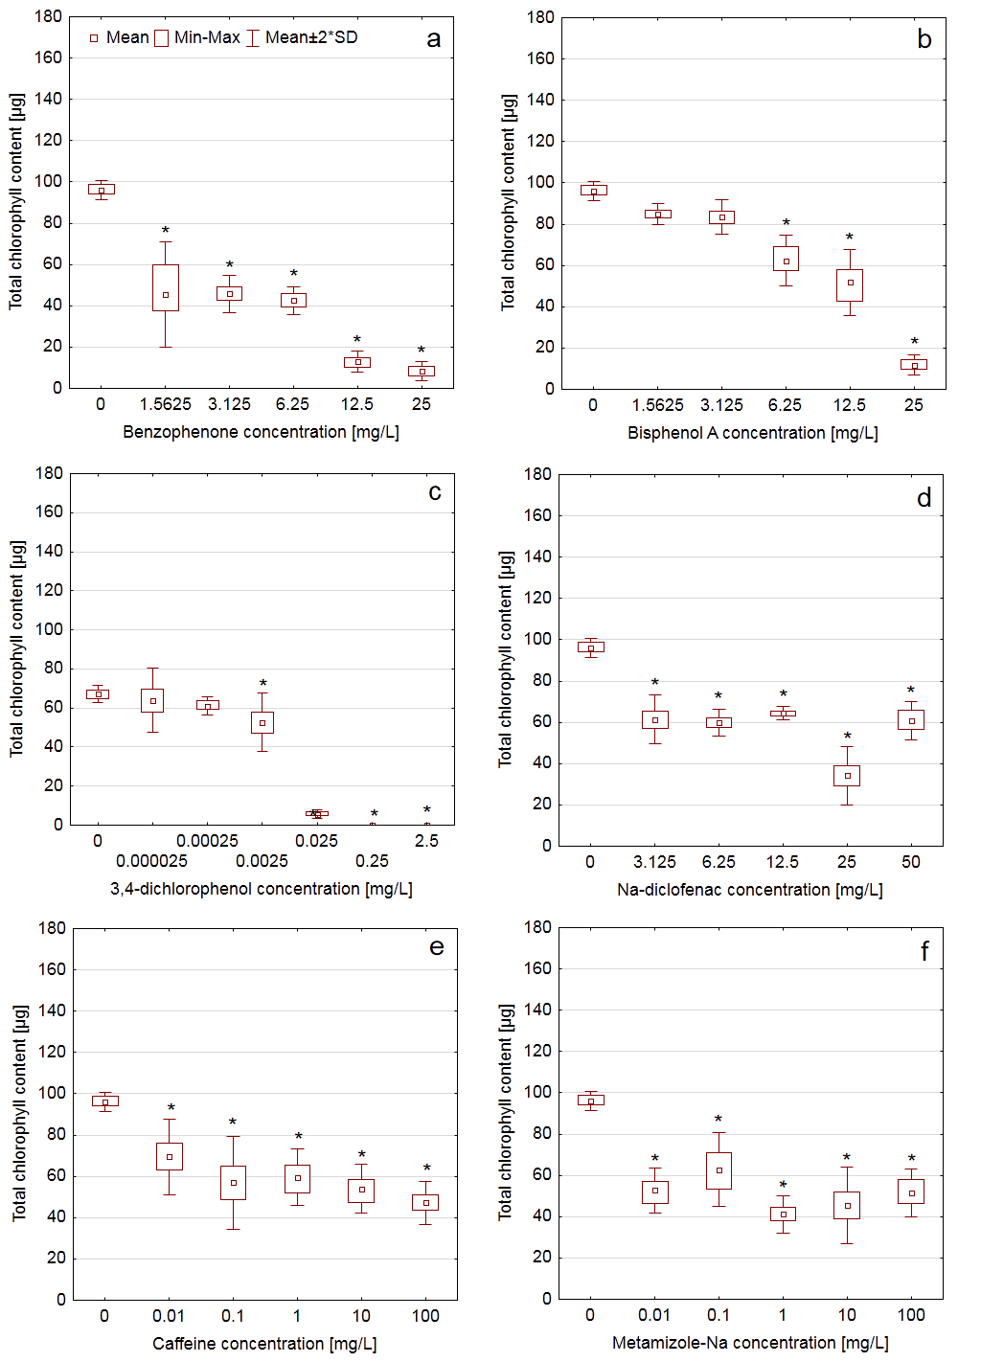
Fig. 2 BoxPlot diagrams of the effect of the applied emerging pollutants on the total chlorophyll content grouped by concentration. Significant inhibition effect is marked by asterisk (*).

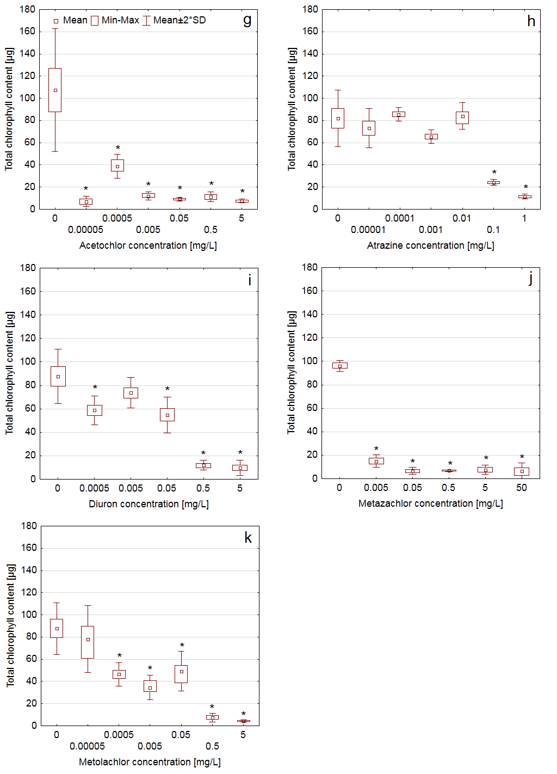
Fig. 3 BoxPlot diagrams of the effect of the applied emerging pollutants on the total chlorophyll content grouped by concentration. Significant inhibition effect is marked by asterisk (*).

concentration range (Fig. 1c). Therefore we found that determination of the total chlorophyll content was a more
Regarding diuron our tests showed similar inhibition values to the results of Teisserie et al. [46]. The applied toxicity endpoint based on the frond number was growth inhibition. They found the EC₅₀ value to be 25 µg/L and the inhibition effect was detected at 5 µg/L concentration. Based on the total chlorophyll content we detected 33% inhibition effect at 0.5 µg/L concentration level. Therefore at 0.5 µg/L diuron concentration the detected significant inhibition effect was higher than for Teiserie et al. [46] (H%=33) therefore the LOEC value was considered to be 0.5 µg/L. Teisserie et al. [46] reported about the increase of the chlorophyll content in the diuron solution compared to the control, but we could not detect this phenomenon. Metazachlor induced 84 H% at 5 µg/L concentration in our experiments, while Müller et al. [45] determined EC₅₀=2.8 µg/L measuring the frond area. We did not find any inhibition effect at 0.5 µg/L concentration, so further experiments are needed to determine the EC₅₀ value between 0.5 and 5 µg/L. Based on the measured data the LOEC value for metazachlor is <5 µg/L. For atrazine EC₅₀=56–153 µg/L data can be found in the current literature [44]. Based on our experiments measuring the frond number and the fresh weight, the LOEC value is 100 µg/L (According to our experiments using bisphenol A measuring frond biomass and frond density at EC₅₀=7.8–32 mg/L (Table 1), the LOEC value is 12.5 mg/L. In terms of the population abundance [42] and the total frond area [41] EC₅₀ values were 47.6 µg/L and 7.5 mg/L respectively for Na-diclofenac (Table 1). In our research the LOEC value is 3.125 mg/L. EC₅₀ value could not be determined, because the inhibition was not concentration dependent, the curve did not exhibit the typical sigmoid shape.
Brain et al. [38] determined the LOEC values of caffeine solutions, they found the LOEC value to be 118 µg/L–4.746 mg/L, while our result was LOEC=10 µg/L based on the total chlorophyll content. In the USEPA/OPP, EFED; Pesticide Ecotoxicity Database [43] EC₅₀ (population abundance) of acetochlor on Lemna gibba is 3.4 µg/L. In our research the LOEC value was 0.05 µg/L. EC₅₀ (population abundance) of metolachlor on Lemna gibba was 21–95400 µg/L.
Based on the statistical analysis Table 3 shows the significant lowest observed effect concentrations of the applied micropollutants determined by the total chlorophyll content.
The measured data clearly show that the L. minor bioassay based on the total chlorophyll content may be an appropriate and sensitive test method to detect the micropollutants in water matrices. In comparison with the
Table 3 LOEC values of the tested chemical substances
Chemical substance | LOEC [mg/L]
Acetochlor | 0.00005
Metolachlor | 0.0005
Diuron | 0.0005
3,4-dichlorophenol | 0.0025
Metazachlor | 0.005
Caffeine | 0.01
Metamizole-Na | 0.01
Atrazine | 0.1
Benzophenone | 1.5625
Na-diclofenac | 3.125
Bisphenol A | 6.25

routinely used test methods it proved to be more sensitive to Na-diclofenac, nicotine and 3,4-dichlorophenol. Further research is needed for the investigation of the non-concentration depending effect and the mode of action.

Conclusion
Duckweeds such as Lemna sp. are key components of freshwater ecosystems. These aquatic vascular plants are active components of many biogeochemical cycles and play vital role as primary producers. The genus Lemna has gained widespread acceptance also as tesorganism in environmental toxicology because of its small size, fast growth rate along with ease of culturing and handling. In ecotoxicity tests applying Lemna minor the most favourable measurement endpoints are the growth parameters (frond number, dry biomass), while the total chlorophyll content is less commonly determined.
Our results proved that Lemna minor bioassay based on determination of the chlorophyll content was highly sensitive to the tested micropollutants. The frond number and the chlorophyll content determinations were directly compared to each other and proved that the frond number was a less sensitive measurement endpoint in the case of nicotine, diclofenac and 3,4-dichlorophenol.
The lowest observed effect concentration values obtained suggested that the duckweed assay maybe used in water quality studies to monitor pesticides (acetochlor, atrazine, diuron, metazachlor, metolachlor) and industrial chemicals (3,4-dichlorophenol) at µg/L concentration level. The Lemna minor bioassay based on determination of the total chlorophyll content may be an ideal test system due to its sensitivity, simple handling, easy culturing and cost-effectiveness.

References
- Kolpin, D.W., Furlong, E.T., Meyer, M.T., Thurman, E.M., Zaugg, S.D., Barber, L.B., Buxton, H.T. “Pharmaceuticals, hormones, and other organic wastewater contaminants in U.S. streams, 1999–2000: a national reconnaissance,” Environ. Sci. Technol. 36, pp. 1202–1211. 2002.
- Daughton, C.G. “Non-regulated water contaminants: emerging research,” Environ. Impact Assess. 24, pp. 711–732. 2004.
- Barnes, K.K., Kolpin, D.W., Furlong, E.T., Zaugg, S.D., Meyer, M.T., Barber, L.B. “A national reconnaissance of pharmaceuticals and other organic wastewater contaminants in the United States – I groundwater,” Sci. Total Environ. 402, pp. 192–200. 2008.
- Loos, R., Gawlik, B.M., Locoro, G., Rimaviciute, E., Contini S., Bidoglio, G. “EU-wide survey of polar organic persistent pollutants in European river waters,” Environ. Pollut. 157, pp. 561–568. 2009.
- Deblonde, T., Cossu-Leguille, C., Hartemann, P. “Emerging pollutants in wastewater: A review of the literature,” Int. J. Hyg. Envir. Heal. 214(6), pp. 442–448. 2011.
- Santos, L.H.M.L.M., Gros, M., Rodriguez-Mozaz, S., Delerue-Matos, C., Pena, A., Barceló, D., Montenegro, M.C.B.S.M. “Contribution of hospital effluents to the load of pharmaceuticals in urban wastewaters: Identification of ecologically relevant pharmaceuticals,” Sci. Total Environ. 461–462, pp. 302–316. 2013.
- Ternes, T.A., Joss, A. “Human Pharmaceuticals, Hormones and Fragrances. The Challenge of Micropollutants in Urban Water Management,” IWA Publishing, London. 2006.
- Oppenheimer, J., Stephenson, R., Burbano, A., Liu, L. “Characterizing the passage of personal care products through wastewater treatment processes,” Water Environ. Res. 79 (13), pp. 2564–2577. 2007.
- Miège, C., Choubert, J.M., Ribeiro, L., Eusèbe, M., Coquery, M. “Removal efficiency of pharmaceuticals and personal care products with varying wastewater treatment processes and operating conditions – conception of a database and first results,” Water. Sci. Technol. 57 (1), pp. 49–56. 2008.
- Radjenovic, J., Petrovic, M., Barceló, D. “Fate and distribution of pharmaceuticals in wastewater and sewage sludge of the conventional activated sludge (CAS) and advanced membrane bioreactor (MBR) treatment,” Water. Res. 43, pp. 831–841. 2009.
- Verlicchi, P., Galletti, A., Petrovic, M., Barceló, D. “Hospital effluents as a source of emerging pollutants: An overview of micropollutants and sustainable treatment options,” J. Hydrol. 389, pp. 416–428. 2010.
- Bergman, A., Heindel, J., Jobling, S., Kidd, K.A., Zoeller, R.T. “State of the science of endocrine disrupting chemicals,” Toxicol. Lett. 211, pp. S3–S3. 2012.
- Rivera-Utrilla, J., Sánchez-Polo, M., Ferro-García, M.A., Prados-Joya, G., Ocampo-Pérez, R. “Pharmaceuticals as emerging contaminants and their removal from water. A review,” Chemosphere 93, pp. 1268–1287. 2013.
- Lapworth, D., Baran, N., Stuart, M., Ward, R. “Emerging organic contaminants in groundwater: a review of sources, fate and occurrence,” Environ. Pollut. 163, pp. 287–303. 2012.
- Post, G.B., Cohn, P.D., Cooper, K.R. “Perfluorooctanoic acid (PFOA), an emerging drinking water contaminant: A critical review of recent literature,” Environ. Res. 116, pp. 93–117. 2012.
- Park, J.S., Brown, M.T., Han, T. “Phenol toxicity to the aquatic macrophyte Lemna paucicostata,” Aquat. Toxicol. 15, pp. 106–107. 2012.
- Park, A., Kim, Y.J., Choi, E.M., Brown, M.T., Han, T. “A novel bioassay using root re-growth in Lemna,” Aquat. Toxicol. 140–141, pp. 415–424. 2013.
- Focazio, M.J., Kolpin, D.W., Barnes, K.K., Furlong, E.T., Meyer, M.T., Zaugg, S.D., Barber, L.B., Thurman, M.E. “A national reconnaissance for pharmaceuticals and other organic wastewater contaminants in the United States – II untreated drinking water sources,” Sci. Total. Environ. 402, pp. 201–216. 2008.
- Bolong, N., Ismail, A.F., Salim, M.R., Matsuura, T. “A review of the effects of emerging contaminants in wastewaters and options for their removal,” Desalination 239, pp. 229–246. 2009.
- Radić, S., Stipaničev, D., Cvjetko, P., Marijanović Rajčić, M., Širac, S., Pevalek-Kozlina, B., Pavlica, M. “Duckweed Lemna minor as a tool for testing toxicity and genotoxicity of surface waters,” Ecotox. Environ. Safe. 74(2), pp. 182–187. 2011.
- Zezulka, S., Kummerova, M., Babula, P., Vanova, L. “Lemna minor exposed to fluoranthene: Growth, biochemical, physiological and histochemical changes,” Aquat. Toxicol. 140–141, pp. 37–47. 2013.
- Paczkowska, M., Kozlowska, M., and Golinski, P. “Oxidative stress enzyme activity in Lemna minor L. exposed to cadmium and lead,” Acta Biol. Cracov. Ser. Bot. 49, 33–37. 2007.
- Carvalho, R.F., Bromilow, R.H., Greenwood, R. “Uptake and translocation of non-ionised pesticides in the emergent aquatic plant parrot feather Myriophyllum aquaticum,” Pest Manag Sci. 63(8), pp. 798–802. 2007.
- Lemna EPA Test, OCSPP 850.4400: “Aquatic Plant Toxicity Test Using Lemna spp.,” [EPA 712-C-008]
- OECD 221, “Guideline, OECD Guidelines for Testing of Chemicals: Lemna sp. Growth Inhibition Test,” 2006.
- Drost, W., Matzke, M., Backhaus, T. “Heavy metal toxicity to Lemna minor: studies on the time dependence of growth inhibition and the recovery after exposure,” Chemosphere 67, pp. 36–43. 2007.
- Dirilgen, N. “Mercury and lead:Assessing thetoxic effects on growth and metal accumulation by Lemna minor,” Ecotox. Environ. Safe. 74, pp. 48–54. 2011.
- Horvat, T., Vidaković-Cifrek, Z., Oreščanin, V., Tkalec, M., Pevalek-Kozlina, B. “Toxicity assessment of heavy metal mixtures by Lemna minor L.,” Sci. Total Environ. 384, pp. 229–238. 2007.
- Gubbins, E.J., Batty, L.C., Lead, J.R. “Phytotoxicity of silver nanoparticles to Lemna minor L.,” Environ. Pollut. 159(6), pp. 1551-1559. 2011.
- Juneau, P., Sumitomo, H., Matsui, S., Itoh, S., Kim, S.G., Popovic, R. “Use of chlorophyll fluorescence of Closterium ehrenbergii and Lemna gibba for toxic effect evaluation of sewage treatment plant effluent and its hydrophobic components,” Ecotox. Environ. Safe. 55(1), pp. 1–8. 2003.
- Gatidou, G., Stasinakis, A.S., Iatrou, E.I. “Assessing single and joint toxicity of three phenylurea herbicides using Lemna minor and Vibrio fischeri bioassays,” Chemosphere. In Press. http://dx.doi.org/10.1016/j.chemosphere.2014.04.030
- Geoffroy, L., Frankart, C., Eullaffroy, P. “Comparison of different physiological parameter responses in Lemna minor and Scenedesmus obliquus exposed to herbicide flumioxazin,” Environ. Pollut. 131(2), pp. 233–241. 2004.
- Kumar, K.S., Han, T. “Toxicity of single and combined herbicides on PSII maximum efficiency of an aquatic higher plant, Lemna sp.,” Toxicol. Environ. Health. Sci. 3(2), pp. 97–105. 2011.
- Megateli, S., Dosnon-Olette, R., Trotel-Aziz, P., Geffard, A., Semsari, S., Couderchet, M. “Simultaneous effects of two fungicides (copper and dimethomorph) on their phytoremediation using Lemna minor,” Ecotoxicology 22(4), pp. 683–692. 2013.
- Olette, R., Couderchet, M., Biagianti, S., Eullaffroy, P. “Toxicity and removal of pesticides by selected aquatic plants,” Chemosphere 70(8), pp. 1414–1421. 2008.
- Cedergreen, N., Abbaspoor, M., Sorensen, H., Streibig, J.C. “Is mixture toxicity measured on a biomarker indicative of what happens on a population level? A study with Lemna minor,” Ecotox. Environ. Safe. 67, pp. 323–332. 2007.
- Gorzerino, C., Quemeneur, A., Hillenweck, A., Baradat, M., Delous. G., Ollitrault, M., Azam, D., Caquet, T., Lagadic, L. “Effects of diquat and fomesafen applied alone and in combination with a nonylphenol polyethoxylate adjuvant on Lemna minor in aquatic indoor microcosms,” Ecotox. Environ. Safe. 72, pp. 802–810. 2009.
- Brain, R.A., Johnson, D.J., Richards, S.M., Hanson, M.L., Sanderson, H., Lam, M.W., Young, C., Mabury, S.A., Sibley, P.K., Solomon, K.R. “Microcosm evaluation of the effects of an eight pharmaceutical mixture to the aquatic macrophytes Lemna gibba and Myriophyllum sibiricum,” Aquat. Toxicol. 70(1), pp. 23–40. 2004.
- Lichtenthaler H.K. “Chlorophylls and carotenoids: Pigments of photosynthetic biomembranes,” Method. Enzymol. 148, pp. 350–382. 1987.
- Mihaich, E.M., Friederich, U., Caspers, N., Hall, A.T., Klecka, G.M., Dimond, S.S., Staples, C.A., Ortego, L.S., Hentges, S.G. “Acute and chronic toxicity testing of bisphenol A with aquatic invertebrates and plants,” Ecotox. Environ. Safe. 72(5), pp. 1392–1399. 2009.
- Cleuvers, M. “Aquatic ecotoxicity of pharmaceuticals including the assessment of combination effects,” Toxicol. Lett. 142(3), pp. 185–194. 2003.
- Quinn, B., Schmidt, W., O’Rourke, K., Hernan, R. Effects of the pharmaceuticals gemfibrozil and diclofenac on biomarker expression in the zebra mussel (Dreissena polymorpha) and their comparison with standardised toxicity tests,” Chemosphere 84(5), pp. 657–663. 2011.
- U. S. Environmental Protection Agency Ecotox Database, http://cfpub.epa.gov/ecotox/
- Kirby, M.F., Sheahan, D.A. “Effects of atrazine, isoproturon, and mecoprop on the macrophyte Lemna minor and the alga Scenedesmus subspicatus,” B. Environ. Contam. Tox. 53(1), pp. 120–126. 1994.
- Müller, R., Berghahn, R., Hilt, S. “Herbicide effects of metazachlor on duckweed (Lemna minor and Spirodela polyrhiza) in test systems with different trophic status and complexity,” J. Environ. Sci. Heal. 45(2), pp. 95–101. 2010.
- Teisseire, H., Couderchet, M., Vernet, G. “Phytotoxicity of diuron alone and in combination with copper or folpet on duckweed (Lemna minor),” Environ. Pollut. 106(1), pp. 39-45. 1999.

